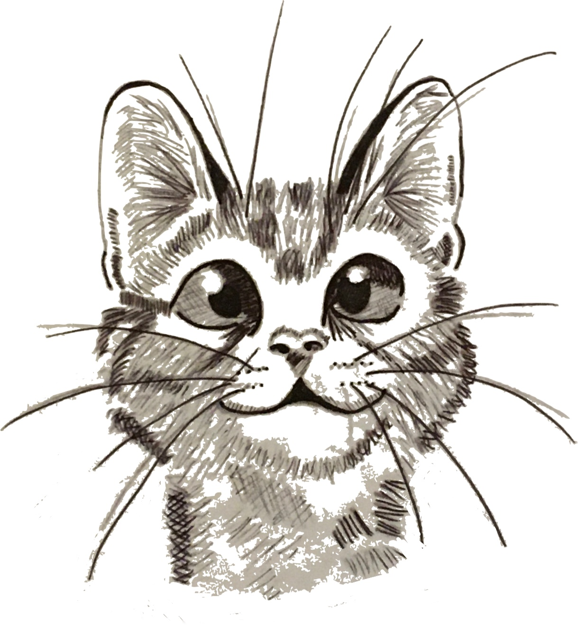
Leek Home for Strays (Charity No. 1045089)
PO Box 4858
UTTOXETER
ST14 9DL

Privacy Statement
Preservation of your privacy is important to the Leek Home for Strays and we are committed to letting you know how we use your personal information and to making only responsible use of your data.
References to “we”, “us”, “you” or “our” in this Privacy Policy are references to the Leek Home for Strays; a charity registered in England and Wales, registered charity number: 1045089.

1. Information about you
1.1 We will collect personal information from you when you or your organisation enquire about our activities, register as a member with us or subscribe to one of our services (e.g. adopting a cat, applying for veterinary support, applying for a voucher or signing a cat over to us). This may include your name, title, email address, physical address, telephone numbers and details of your animal. We may also ask for some additional, non-personal information. We may also ask for proof of identity or proof of any government assistance you are in receipt of. Proof of identity or proof of government assistance will not be held electronically. We also hold this information to send you a Christmas card or to thank you for a donation.

2. Our use of this information
2.1 Your personal information will only be used to process your requests, to provide you with our services, and to provide you with information relating to our services and all other services which we think you may be interested in.
2.2 We will only share your information with our partners which currently includes Agria Pet Insurance, Leek Vets and Foxtwood Kennels. We may also share your information with other parties if we have asked your permission to do so.

3. Security
3.1 We will take reasonable precautions to prevent the loss, misuse or alteration of information you give us.
3.2 Communications in connection with our service may be sent by e-mail. For ease of use and compatibility, communications (other than payments where applicable) will not be sent in an encrypted form unless you require it and provide the certification to enable us to communicate with you in that way. E-mail unless encrypted is not a fully secure means of communication. Whilst we endeavour to keep our systems and communications protected against viruses and other harmful effects we cannot bear responsibility for all communications being virus-free.

4. Cookies
4.1 If cookies are used they will only be used to assist the purposes set out in this privacy policy, but cookies will not be used if we do not consider them to be necessary.

5. Other information
5.1 If you would like us to correct or update any information, or if you would like information deleted from our records, then please phone us on 07791693954, write to us at Leek Home for Strays, PO Box 4858, Uttoxeter, ST14 9DL or email us at leekhomeforstrays@aol.co.uk
5.2 This privacy policy may be updated from time to time, so please check it periodically.
5.3 Links within our sites to other websites are not covered by this privacy policy.

